Day-4 Documentation :
Name:Yaramala Karthik Reddy
Intern Id:28
Date:19-12-2025
10:00 AM – 11:00 AM
🔹 Topic: Renders & Re-renders (Core Understanding)
What was done
- Created a simple React component
- Added console.log() inside components
- Observed when the component renders
What was observed in console
- Component renders once on initial load
- Component re-renders on every state change
Key understanding
- Render → First time component loads
- Re-render → Component function runs again due to state/props change
- State update always triggers re-render
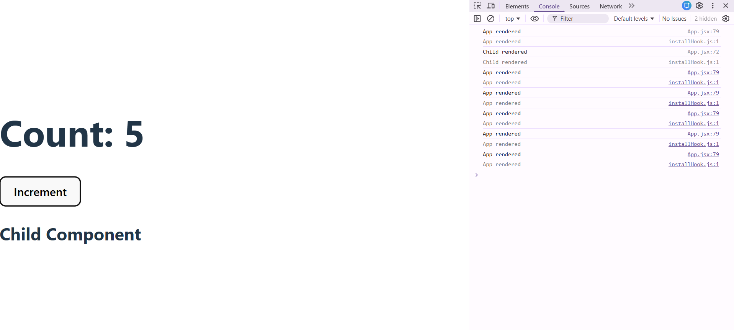
11:00 AM – 12:00 PM
🔹 Topic: Unnecessary Re-renders & React.memo
What was done
- Created a Parent and Child component
- Updated state only in Parent
- Checked console logs
Problem observed
- Child component re-rendered even when its data didn’t change
Solution implemented
- Wrapped Child component using React.memo
Key understanding
- Parent re-render causes child re-render by default
- React.memo prevents child re-render if props don’t change
- Useful for performance optimization

12:00 PM – 1:15 PM
🔹 Topic: useMemo & useCallback
useMemo
What was done
- Added an expensive calculation
- Logged when calculation runs
Observation
- Without useMemo: calculation runs on every render
- With useMemo: calculation runs only when dependency changes
Learning
- useMemo is used to cache values
- Prevents unnecessary heavy computations
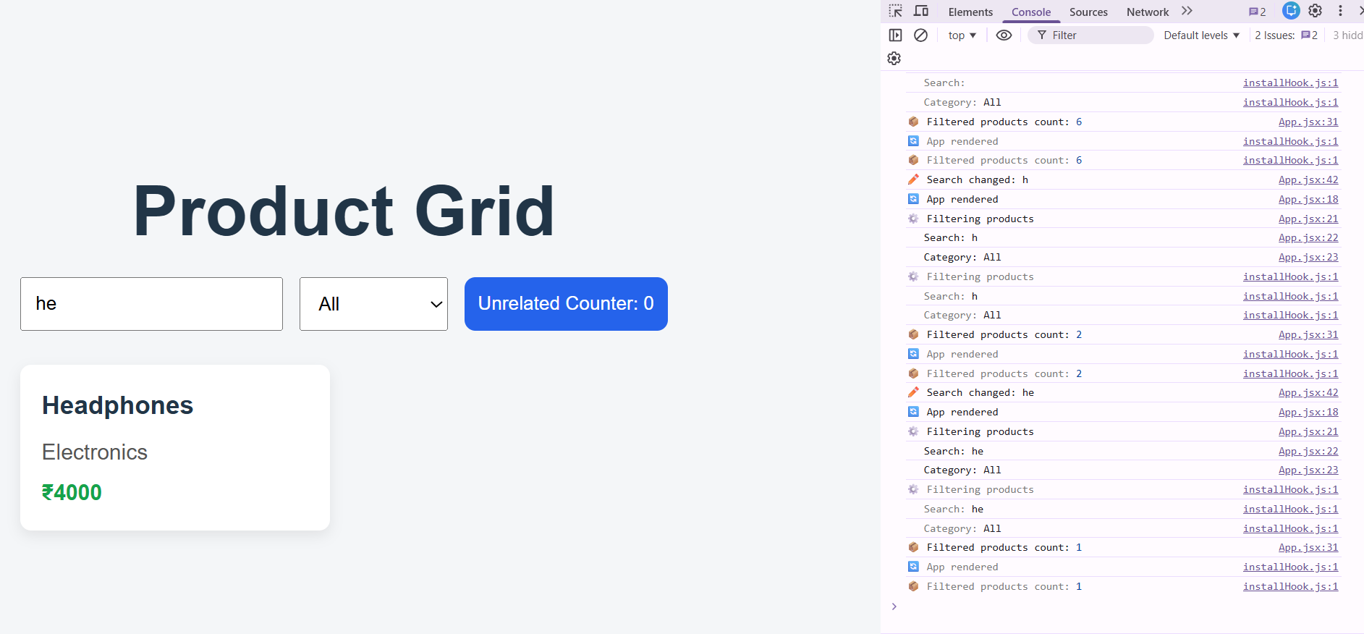

useCallback
What was done
- Passed a function from Parent to Child
- Observed child re-renders
Observation
- New function reference caused child re-render
- useCallback fixed this issue
Learning
- useCallback is used to cache functions
- Works best with React.memo
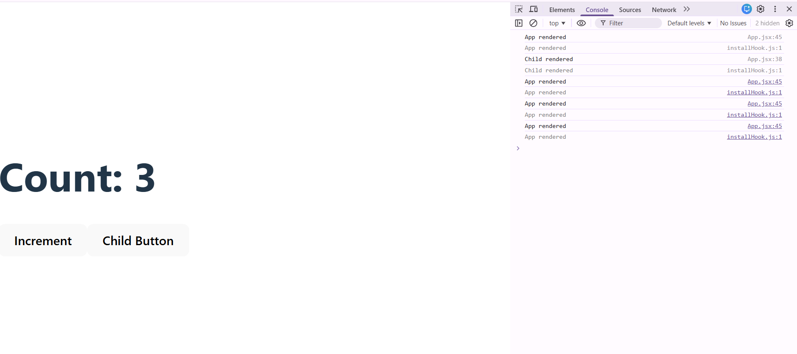

Today’s Task – Key Learnings
- Implemented a stopwatch using repeated time-based execution.
- Learned how setInterval is used to update time at regular intervals.
- Understood that setInterval must be started and stopped based on application state.
- Observed that changing state causes the component to re-render.
- Learned how to control interval execution using a boolean flag.
- Understood the importance of clearing intervals to avoid multiple timers running.
- Identified how improper interval handling can lead to memory leaks.
- Learned how cleanup logic stops background execution when the task is no longer active.
- Observed real-time state updates reflected immediately in the UI.
- Used console logs to track renders, timer start, timer stop, and interval cleanup.
Today’s One-Line Learning
A controlled setInterval can be safely used in React to build a stopwatch when it is properly started, stopped, and cleaned up using state-driven logic.
Output/ Delivarble:
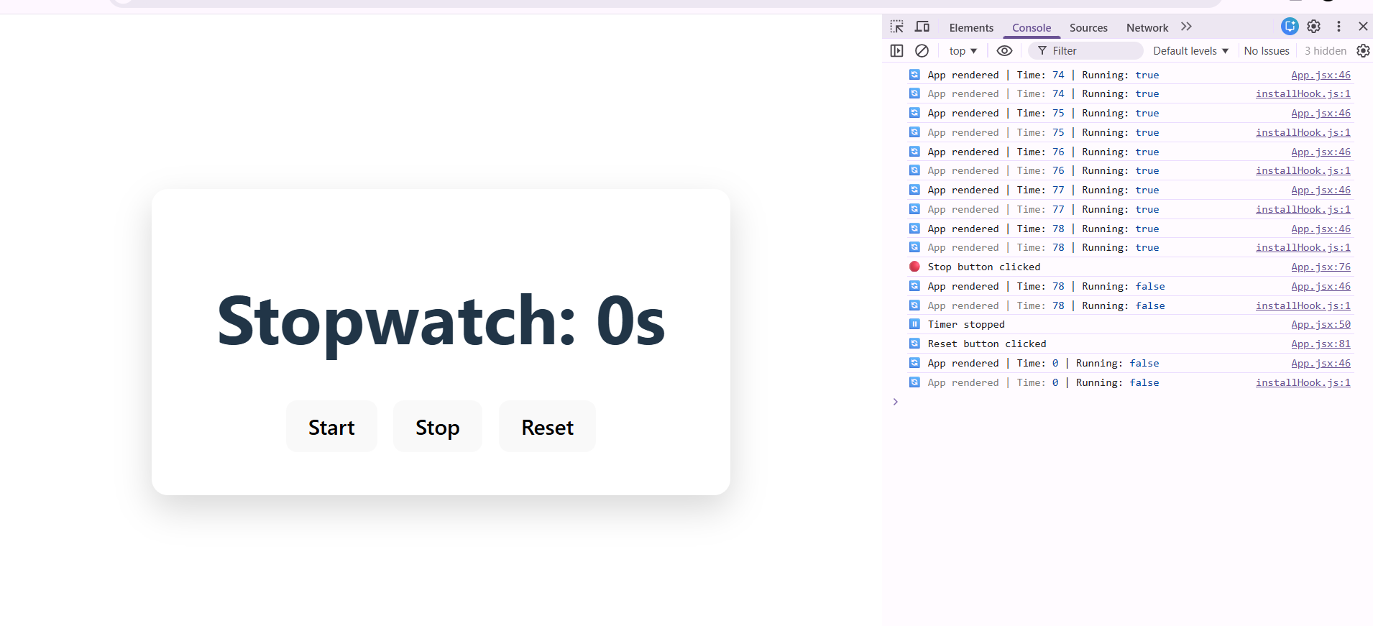
2:15 PM – 3:15 PM
🔹 Topic: External API & Infinite Scroll
What was done
- Integrated JSONPlaceholder API
- Implemented infinite scroll using Intersection Observer
Issues faced
- Duplicate API calls
- Duplicate keys warning in console
Fix applied
- Added loading guard
- Added hasMore condition
- De-duplicated data by id
Learning
- Infinite scroll must:
  - Prevent parallel API calls
  - Stop after last page
  - Ensure unique keys
  - 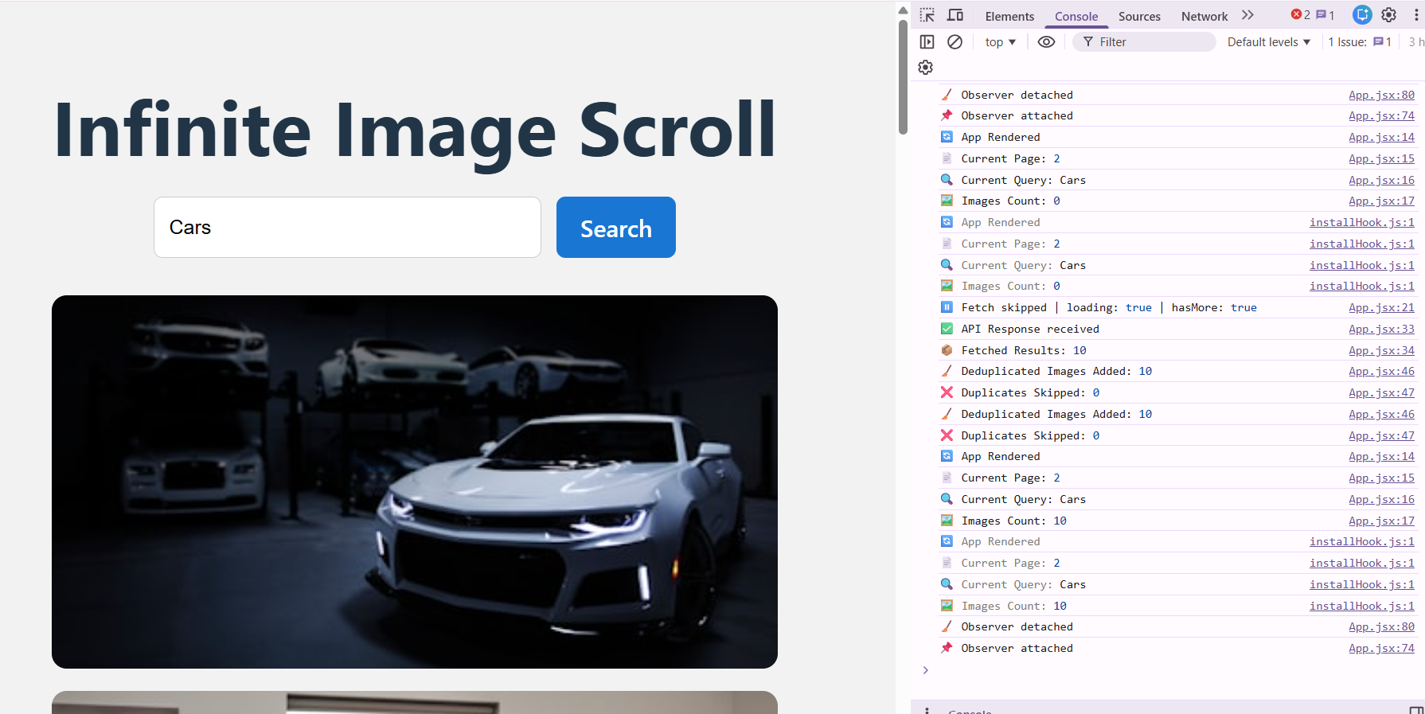

3:15 PM – 4:30 PM
🔹 Topic: Debugging with Console Logs
What was done
- Logged renders in:
  - App component
  - List component
  - Item component
- Logged API fetch events
- Logged expensive calculations
Outcome
- Clear understanding of:
  - What renders
  - Why it renders
  - When memoization works
4:45 PM – 6:30 PM
🔹 Task Work (Final Integration)
Final App Includes
- Renders & re-renders demonstration
- React.memo
- useMemo
- useCallback
- External API
- Infinite scrolling
- Console-based debugging
Final Learning Outcome
- Can identify performance issues
- Can fix unnecessary re-renders
- Can safely implement infinite scroll
- Can explain React performance clearly
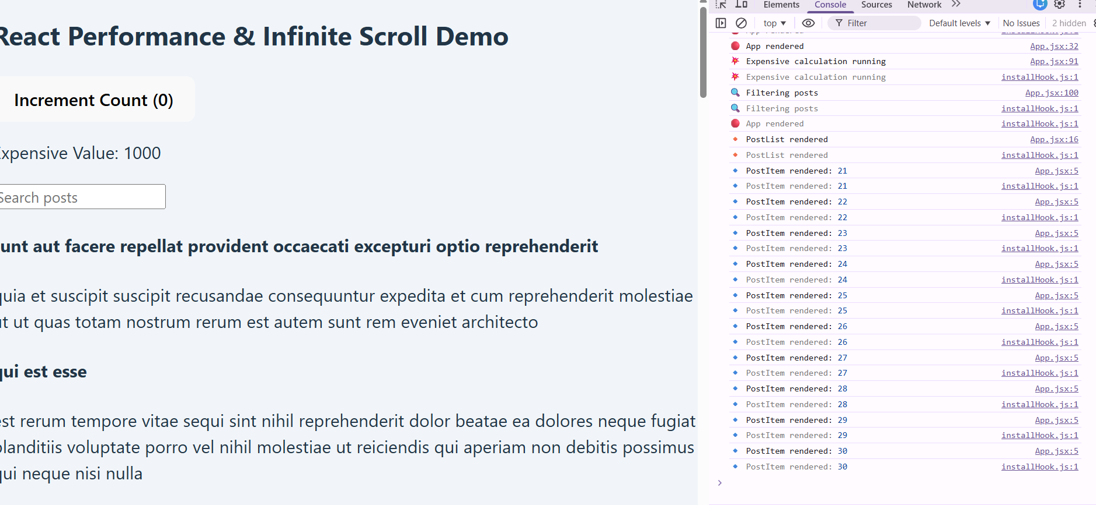
FINAL DAY-4 CONCLUSION
Day-4 focused on understanding how React works internally rather than UI design.
By observing console logs, I learned how components render, re-render, and how memoization improves performance.
This knowledge is essential for building scalable and optimized React applications.

